LPC32x0 NOR Flash Utility implementation

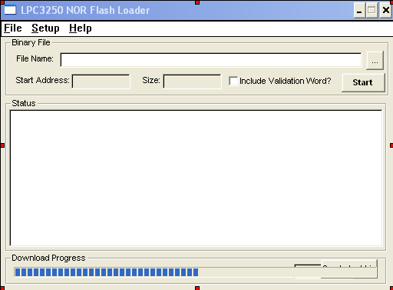

Above is the main window of the utility. In the Binary File group of controls, the File Name is a variable which holds the binary file name to be burned into the NOR Flash. Once the binary file is determined, the utility can know the size and refresh the size variable (read only). The start address is a read only variable which is prefixed with 0xE0000000, but it could be changed so the utility can burn the binary file starting from any other memory address. The include Validation Word variable is a check which determines if the Validation Word (see User’s Manual) should be burned at address 0xE0000000. If this option is not used, the binary file should take care of this. Also, if different Start Address is being implemented, the Include Validation Word logic should be changed as it needs to be burned at the same fixed address (0xE0000000).
The utility also has the capability to save and restore the settings via INI files. So, each time the utility is opened, the INI file is read and the last setting is restored. Also, each time a variable is changed, the INI file is updated.

The status window shows the progress in the whole process, while the Download Progress bar shows the progress in the user’s binary download process.

General Description

The LPC32x0 has a built-in Boot ROM which support several boot options. The boot process can identify, copy to internal SRAM (iRAM) and execute an external program from external sources such UART5 (or USB transceiver), NAND Flash, and SPI using SSP0.

In our case, we are using the UART5 boot capability in order to download a program (the Loader code in our case) into iRAM and execute it. Once our Loader code is running, we re-use the same communication channel (UART5) in order to download the user’s binary file and burn it into the NOR Flash, which is ultimately the main objective.

The above means our utility will need to detect when the LPC32x0 is booting from UART5 (it sends the BootID char ‘5’) and initiate the handshaking sending the ‘A’ char. The following picture shows the handshake;

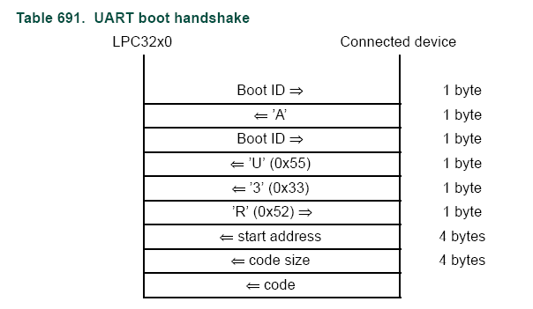

In this case, the utility sends the start address (0x00), size, and code of the Loader project (Keil’s project for the target). Once this code is downloaded into the iRAM, it starts execution.

Once the Loader code is running on the LPC32x0, it will send a ‘D’ char in order to start a new handshaking. In this case, we implemented a specific protocol in order to let the utility knows that the Loader code is running. After this, the utility sends the starting address where the code should be burned to (0xE0000000) and the size of the user’s binary file. With this information, the Loader code knows how many bytes to expect from the utility.

In order to start downloading the user’s binary image, the Loader sends a ‘S’ char and the utility sends 32K of data to be burned. This data is written in an internal buffer and then, burned into the NOR Flash. The target continues sending a ‘S’ char in order to receive more data, until the complete image is downloaded from the utility and burned into the NOR Flash. When this happens, the Loader sends a ‘F’ char so the utility knows everything was completed. If something goes wrong (error programming the Flash), an ‘E’ char is sent so the utility gets notified.

Code Explanation

When the user presses the Start button, the following code is executed;

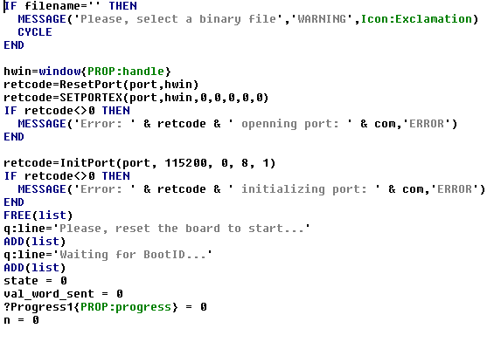
The above code checks the filename variable is not empty (that is, it should contain the user’s binary file name). After this, the COM port is opened and some initialization is done with the variables. Also, messages are shown to the user.

After this, the utility will check the COM port for the ‘5’ char (BootID) in order to start the handshaking. When this happens, the complete sequence is started. The following code is executed in a Timer routine (that is, this code is called every 1ms;

retcode = ComGetc(port)
IF retcode NOT= -1 THEN
char = retcode
case state
OF 0
IF CHR(char) <> '5' THEN
RETURN 0
END
q:line = 'Waiting for BootID...Found!'
PUT(list)
ComPutc(port, VAL('A'))
state=1
q:line = 'Waiting for BootID...Found! Sent char A'
PUT(list)
q:line = 'Waiting for BootID...'
ADD(list)
OF 1
IF CHR(char) <> '5' THEN
RETURN 0
END
q:line = 'Waiting for BootID...Found!'
PUT(list)
ComPutc(port, VAL('U'))
ComPutc(port, VAL('3'))
state=2
q:line = 'Waiting for BootID...Found! Sent chars U3'
PUT(list)
q:line = 'Waiting for confirmation...'
ADD(list)
OF 2
IF CHR(char) <> 'R' THEN
RETURN 0
END
q:line = 'Waiting for confirmation...Found!'
PUT(list)
ComPutc(port, 0)
ComPutc(port, 0)
ComPutc(port, 0)
ComPutc(port, 0)
q:line = 'Downloading Loader...'
ADD(list)

i#=RECORDS(loader)
i1#=INT(i#/(256*256*256))
i2#=INT(i#/(256*256))
i3#=INT(i#/(256))
i4#=i# - (i1# * 256 * 256 * 256) - (i2# * 256 * 256) - (i3# * 256)
ComPutc(port, i4#)
ComPutc(port, i3#)
ComPutc(port, i2#)
ComPutc(port, i1#)

SET(loader)
LOOP
NEXT(loader)
IF ERRORCODE() THEN
IF ERRORCODE()<>33 THEN
MESSAGE('Error: ' & ERROR() & ' reading loader file','ERROR')
END
BREAK
END
ComPutc(port, LOA:data)
END
q:line = 'Downloading Loader...Completed!'
PUT(list)
state=3
q:line = 'Waiting for Loader...'
ADD(list)
OF 3
IF CHR(char) = 'e' THEN
q:line = 'Error Initializing Flash'
ADD(list)
state = 5
retcode=ResetPort(port,hwin)
RETURN 0
END
IF CHR(char) = 'E' THEN
q:line = 'Error Erasing Flash'
ADD(list)
state = 5
retcode=ResetPort(port,hwin)
RETURN 0
END
IF CHR(char) <> 'D' THEN
RETURN 0
END
q:line = 'Waiting for Loader...Ok!'
PUT(list)

i#=0E0000000h !startAddress
i1#=INT(i#/(256*256*256))
i2#=INT(i#/(256*256))
i3#=INT(i#/(256))
i4#=i# - (i1# * 256 * 256 * 256) - (i2# * 256 * 256) - (i3# * 256)
ComPutc(port, i4#)
ComPutc(port, i3#)
ComPutc(port, i2#)
ComPutc(port, i1#)

i#=size
IF val_word THEN
i#+=4
END
i1#=INT(i#/(256*256*256))
i2#=INT(i#/(256*256))
i3#=INT(i#/(256))
i4#=i# - (i1# * 256 * 256 * 256) - (i2# * 256 * 256) - (i3# * 256)
ComPutc(port, i4#)
ComPutc(port, i3#)
ComPutc(port, i2#)
ComPutc(port, i1#)

?Progress1{PROP:rangehigh} = 100
?Progress1{PROP:rangelow} = 0

index = 1
EOF = 0
SET(bin)
q:line = 'Downloading binary...'
ADD(list)
state = 4

OF 4
IF CHR(char) = 'E' THEN
q:line = 'Error Programming Flash'
ADD(list)
state = 5
retcode=ResetPort(port,hwin)
RETURN 0
END
IF CHR(char) = 'F' THEN
q:line = 'Downloading binary...Finished!'
PUT(list)
state = 5
retcode=ResetPort(port,hwin)
RETURN 0
END

IF CHR(char) <> 'S' THEN
RETURN 0
END
IF val_word AND NOT val_word_sent THEN
Computc(port, 0D2h)
Computc(port, 09Bh)
Computc(port, 057h)
Computc(port, 013h)
index+=4
val_word_sent = 1
END
LOOP
IF EOF THEN
Computc(port, 0FFh)
ELSE
NEXT(bin)
IF ERRORCODE() THEN
IF ERRORCODE()<>33 THEN
MESSAGE('Error: ' & ERROR() & ' reading loader file','ERROR')
END
EOF = 1
CYCLE
END
ComPutc(port, BIN:data)
END
n += 1
?Progress1{PROP:Progress} = (n / size) * 100
DISPLAY
IF index =32768 THEN
index = 1
RETURN 0
ELSE
index+=1
END
END

OF 5
ELSE

END
?list1{PROP:VScrollPos}=9999
END

Please, ask me for specific questions about the above code.

